Practical No: 10
Name:- Danish Altaf Solkar Enrolment No:- 24111590805
Class:- CO3KB Subject:- CGR
Aim :- WAP for 3D Translation
Program :-
#include <stdio.h>
#include <conio.h>
#include <graphics.h>
int x1 = 100, y1 = 100, x2 = 200, y2 = 200, depth = 50;
// Function to draw a rectangle
void drawRectangle(int x1, int y1, int x2, int y2) {
rectangle(x1, y1, x2, y2);
}
// Function to draw lines connecting the rectangles
to form a 3D box
void drawLines(int x1, int y1, int x2, int y2, int
depth) {
line(x1, y1, x1 + depth, y1 + depth);
line(x2, y1, x2 + depth, y1 + depth);
line(x1, y2, x1 + depth, y2 + depth);
line(x2, y2, x2 + depth, y2 + depth);
}
// Function to perform 3D translation
void trans(int x1, int y1, int x2, int y2, int depth) {
int tx, ty;
// Input the translation factors
printf("Enter the translation factors (tx, ty): ");
scanf("%d %d", &tx, &ty);
// Clear the screen
cleardevice();
// Translate and redraw the 3D box

drawRectangle(x1 + tx, y1 + ty, x2 + tx, y2 + ty);
drawRectangle(x1 + depth + tx, y1 + depth + ty, x2 +
depth + tx, y2 + depth + ty);
drawLines(x1 + tx, y1 + ty, x2 + tx, y2 + ty,depth);
}
int main() {
int gd = DETECT, gm;
char driver[] = "C:\\Turboc3\\BGI"; // Path to
BGI files
initgraph(&gd, &gm, driver);
if (graphresult() != grOk)
{
printf("Graphics error: %s\n",
grapherrormsg(graphresult()));
return 1;
}
// Initial drawing
drawRectangle(x1, y1, x2, y2);
drawRectangle(x1 + depth, y1 + depth, x2 +
depth, y2 + depth);
drawLines(x1, y1, x2, y2, depth);
// Perform translation
trans(x1, y1, x2, y2, depth);
getch();
closegraph();
return 0;
}
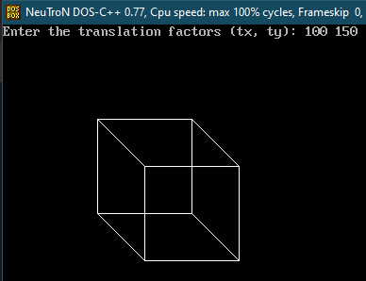
OUTPUT :-
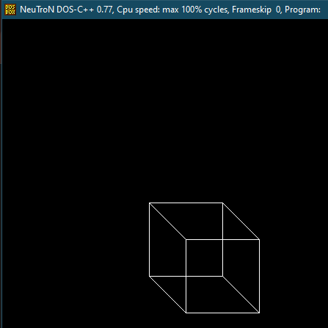

Aim :- WAP for 3D Scaling
Program :-
#include <stdio.h>
#include <conio.h>
#include <graphics.h>
int x1 = 100, y1 = 100, x2 = 200, y2 = 200, depth = 50;
// Function to draw a rectangle
void drawRectangle(int x1, int y1, int x2, int y2) {
rectangle(x1, y1, x2, y2);
}
// Function to draw lines connecting the rectangles to form a 3D box
void drawLines(int x1, int y1, int x2, int y2, int depth) {
line(x1, y1, x1 + depth, y1 + depth);
line(x2, y1, x2 + depth, y1 + depth);
line(x1, y2, x1 + depth, y2 + depth);
line(x2, y2, x2 + depth, y2 + depth);
}
// Function to perform 3D translation
void trans(int x1, int y1, int x2, int y2, int depth) {
int tx, ty;
// Input the translation factors
printf("Enter the translation factors (tx, ty): ");
scanf("%d %d", &tx, &ty);
// Clear the screen
cleardevice();
// Translate and redraw the 3D box
drawRectangle(x1 + tx, y1 + ty, x2 + tx, y2 + ty);
drawRectangle(x1 + depth + tx, y1 + depth + ty, x2 + depth + tx, y2 + depth + ty);
drawLines(x1 + tx, y1 + ty, x2 + tx, y2 + ty, depth);
}
// Function to perform scaling
void scale(int *x1, int *y1, int *x2, int *y2, int *depth) {
float sx, sy;

// Input the scaling factors
printf("Enter the scaling factors (sx, sy): ");
scanf("%f %f", &sx, &sy);
// Scale the coordinates
*x1 = *x1 * sx;
*y1 = *y1 * sy;
*x2 = *x2 * sx;
*y2 = *y2 * sy;
*depth = *depth * sx; // Assuming uniform scaling for depth
}
int main() {
int gd = DETECT, gm;
char driver[] = "C:\\Turboc3\\BGI"; // Path to BGI files
initgraph(&gd, &gm, driver);
if (graphresult() != grOk) {
printf("Graphics error: %s\n", grapherrormsg(graphresult()));
return 1;
}
// Initial drawing
drawRectangle(x1, y1, x2, y2);
drawRectangle(x1 + depth, y1 + depth, x2 + depth, y2 + depth);
drawLines(x1, y1, x2, y2, depth);
// Perform scaling
scale(&x1, &y1, &x2, &y2, &depth);
// Redraw after scaling
cleardevice();
drawRectangle(x1, y1, x2, y2);
drawRectangle(x1 + depth, y1 + depth, x2 + depth, y2 + depth);
drawLines(x1, y1, x2, y2, depth);
getch();
closegraph();
return 0;
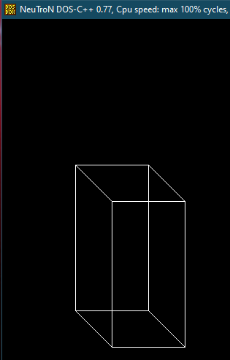
}
OUTPUT :-
